**The International PAOT Workshop**

**Work Improvement for Farmers in the Central Highlands Vietnam**

**(23-30 August 2025)**

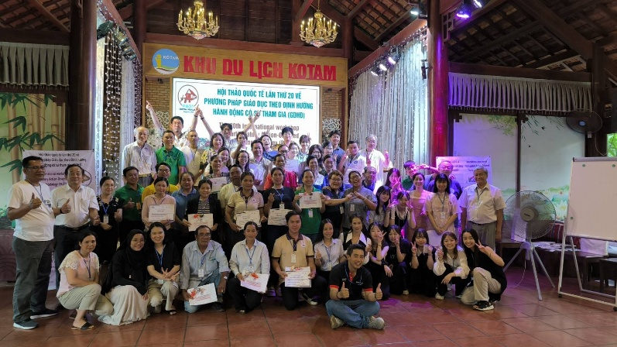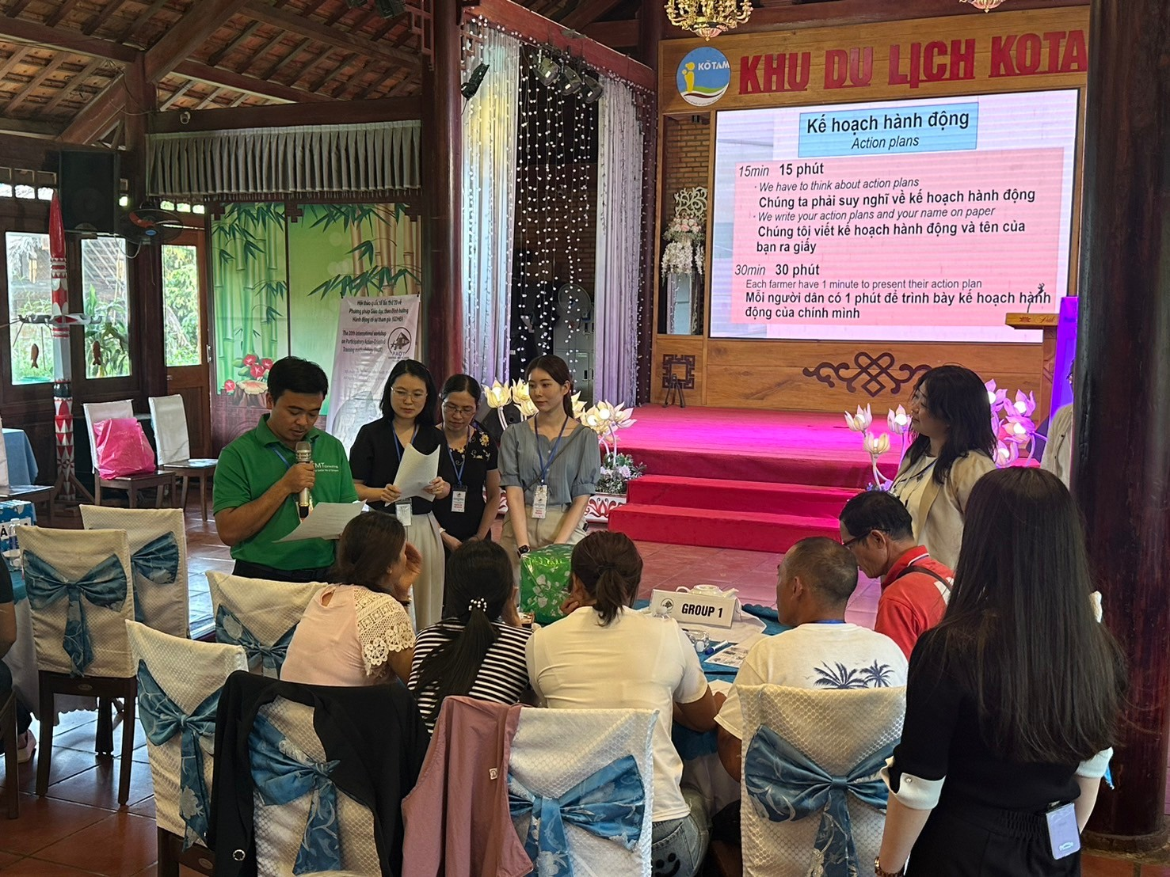

**Participatory Action-Oriented Training has been extended**

**to various occupational safety and health sectors.**

　Since the International Labour Organization (ILO) developed WISE (Work Improvement in Small Enterprises) programme in the 1980s, its training method called PAOT (Participatory Action-Oriented Training) has been extended to various sectors on occupational safety and health. WIND（Work Improvement in Neighbourhood Development）is a typical programme for farmers that originated in the Mekong Delta of Vietnam.

**Two-way communication with ethnic farmers**

　The Mekong Delta International PAOT Workshop started in 2000 as an annual event with hundreds of participants from twenty countries. Last year, we moved the venue to the Central Highlands of Vietnam, and ran the WIND programme for ethnic coffee farmers of the Ede people. Participants learn how to plan and run a PAOT workshop, and farmers implement action plans developed in PAOT workshops. Two-way communication between the participants and farmers is the hallmark of PAOT.

**A valuable opportunity to learn practical PAOT**

　The main facilitator is Dr. Ton That Khai, one of the developers of WIND. You will touch the feeling of growing economy and culture of Vietnam through the workshop, as well as passionate PAOT.

We are looking forward to your participation!

―――――――――――――――――――――――――――――――――――――――――――――

**「The Mekong Delta Fund」steering committee**

　 Director　Dr. Toshio Hirano（Tokyo Occupational Safety and Health Center）

　 Advisor　Dr. Kazutaka Kogi、Dr. Tsuyoshi Kawakami (（The Ohara Memorial Institute of Science of Labour）, Ton That Khai, Nguyen Phuong Toai

　Address: PC 136-0071 7-10-1 Z Building 5F Kameido Koto-ku, Tokyo, Japan

Tokyo Occupational Safety and Health Center

Secretariat: Toyoki Nakao

　　　　TEL: +81 33683-9765　Fax: +81 33683-9766　Email: center02@toshc.org

**Schedule**

Date： 23 (Sat)-30 (Sat) August 2025　(8 days and 7 nights)

Place： Buon MaThuot City, Vietnam

23（Sat） 15:30、Meeting at Tan Son Nhat International Airport International Exit.

　　　　　　　 （Transfer to domestic line　18:30 Ho Chi Minh ⇒ 21:00 Buon MaThuot）

24（Sun） Opening Ceremony, Learning PAOT Methodology Night: Welcome Party

25（Mon） Morning: Farm and factory visit Afternoon: Workshop preparation

26 （Tues）Morning: Workshop preparation Afternoon: General rehearsal

27 （Wed） WIND Workshop

28 （Thurs）Morning: Achievement workshop Afternoon: Free

29 （Fri）　 Buon MaThuot Medical University and Hospital Exchange Programme

30 （Sat）　Morning: Sightseeing　Afternoon: 13：00　Leaving at Buon MaThuot Aitrport

Training Fee： 900 USD

（not including air tickets of domestic and international air tickets, passport application etc.）

Number of participants: 20（arrival order）

Deadline： **31 May（Saturday）**

How to apply：Please send the following application form to the Steering Committee email address.

――――――――――――――――――――――――――――――――――――――――――――――

**I agree with the application guidelines and apply for the International PAOT Workshop in the Central Highlands of Vietnam.**

**Day Month 2025**

|  |  |
| --- | --- |
| Name |  |
| Gender | Male Female |
| Email |  |
| Mobile phone |  |
| Address |  |
| Occupation |  |
| Workplace/School address |  |
| Emergency contact name |  |
| Emergency contact phone |  |

Email: [center02@toshc.org](mailto:center02@toshc.org) FAX:+81-33683-9766

**The application guideline of the International PAOT Workshop**

**In the Central Highlands Vietnam**

【Purposes】

1.　To learn about participatory action-oriented occupational safety and health improvement in Vietnam.

2.　To exchange activities and researches of the participants.

3.　To contribute to international PAOT activities.

【Schedule】23 (Sat）～ 30（Sat）August 2025　(8 days and 7 nights)

Point of meeting： 23（Sat）15:30 Tan Son Nhat International Airport arrival exit（1F）

point of disbanding: 30（Sat）13:00 Buon Ma Thuot Airport

【Host and Training location】

Host：TMT Consulting　　　URL: https://tmt.org.vn/

（Address：08 Võ Duy Thanh, Phường Tân An, Tp Buôn Ma Thuột, tỉnh Đăk Lăk）

Location：Buon Ma Thuot City, Vietnam

【Applicant】

People who are interested in international cooperation, safety and health and environmental protection, and who want to learn PAOT in a positive way.

【Number of participants】

20 （Arrival order）

【Deadline】

**31 May（Sat）2025**

【Training fee】

**900 USD**

（It includes 7 days accommodation fee, party fees, training kits. It does not include air tickets（International・Domestic）、passport application fee、travel insurance）

【Hotel and local transportation】

We serve hotel in Buon Ma Thuot City（twin room. If you stay single room, extra charge required）.

Maximum attention will be paid by the steering committee, and buses will be chartered for local transportation.

【Language】 English

【Safety Measures】

**The Steering Committee will make every effort to prevent sudden disasters, But you must take responsibility for yourself during the training. The Steering Committee cannot be held responsible for any sudden accidents or disasters. Please ensure that you act with restraint and make your own arrangements for overseas travel insurance.**

【How to apply】

**This workshop is not study tour. It is a self-directed application for a training to be held at Buon Ma Thuot City by the local initiative.** Please complete the application form and send it to the Steering Committee email address by the deadline.